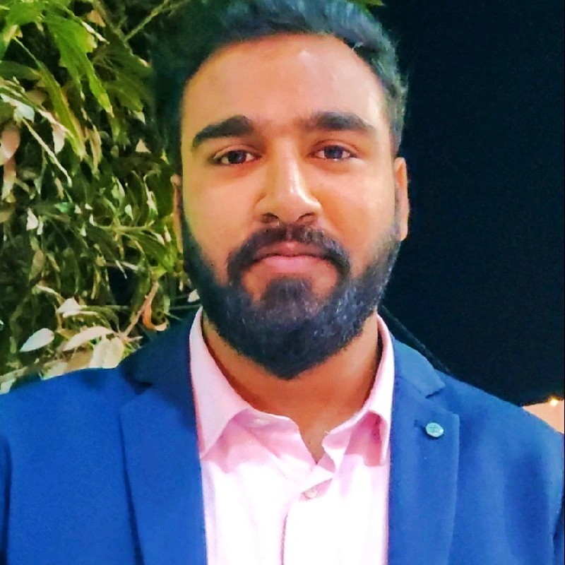

**Registration No.:** 21BCE10780

**Email: lakshraj.lrk@gmail.com**

**LinkedIn:** https://www.linkedin.com/in/laksh-raj-kumar-330a9b21a

**GitHub:** <https://github.com/lakshrajkumar26>

**Portfolio:**https://github.com/lakshrajkumar26/portfolio

**Laksh Raj Kumar**

**Technical Skills:** C++, HTML, CSS, JavaScript, React.js , Node.js ,Tailwind ,Bootstrap

**Certifications:** Software Test Automation Virtual Internship | Katalon

|  |  |  |  |
| --- | --- | --- | --- |
| EDUCATION | | | |
| Board | Tenure | Educational Institution | CGPA/Percentage |
| B. Tech Computer Science Engineering | Aug 2021 - Ongoing | VIT Bhopal University | 6.52 |
| Class XII | May 2020 | New Tehri International School,U.K | 65.50% |
| Class X | May 2018 | All Saints Convent School, U.K | 62.20% |

|  |  |
| --- | --- |
| ACADEMIC PROJECTS | |
| Project Title | Description |
| 1. Amazon clone | * + Developed a clone of Amazon Leveraging HTML and CSS, I meticulously crafted a faithful representation of Amazon's user interface, focusing on key features such as product listings, search functionality, and intuitive navigation. * **Technology:** HTML, CSS * https://github.com/lakshrajkumar26/Amazon_Clone |
| 1. NewsMonkey App | Developed a robust web app for scheduling tasks, Developed a dynamic News Application leveraging React.js, Bootstrap, and React Router for seamless navigation. Implemented key features such as Dark Mode, Alert messages, and Infinite Scroll for enhanced user experience. Employed useState Hook and React Hooks for efficient state management and functional components for optimized performance. Integrated APIs using Fetch API for real-time data updates. Ensured code scalability and maintainability through refactoring and PropTypes usage. Hosted the application on GitHub Pages after domain purchase, demonstrating proficiency in deployment and domain management. Applied advanced concepts including Component lifecycle and Environment variables for robust application functionality. Proactively addressed bugs, showcasing strong problem-solving skills and attention to detail.   * **Technology:** React, Routing, Bootstrap * https://github.com/lakshrajkumar26/newsx_app |
| 1. Asharya Website | * + Developed a front end website for Old age Home leveraging HTML and CSS, and meticulously crafted a user interface, focusing on understanding every basic and key features such as  Proficient in structuring web pages with essential HTML components: <html>, <head>, and <body>, ensuring proper organization and functionality. Utilizes Semantic HTML elements like <header>, <nav>, <main>, <section>, <article>, and <footer> to enhance accessibility and SEO. Skilled in applying CSS properties, including color, font, spacing, alignment, and background, to achieve visually appealing designs. Implements CSS media queries for responsive design, ensuring websites adapt seamlessly across various devices and screen sizes. Ensures accessibility through proper HTML structures, semantic markup, and integration of ARIA attributes, catering to diverse user needs. Proficient in creating navigation menus using HTML lists (<ul>, <li>), facilitating intuitive user navigation. Capable of incorporating multimedia elements such as <img>, <video>, and <audio> to enrich content presentation. Experienced in designing forms with <form>, <input>, <textarea>, and <select> elements, enabling effective data collection and interaction. Utilizes CSS properties for typography, including font selection, size, line spacing, and alignment, to enhance readability and visual appeal. Knowledgeable about layout techniques such as floats, flexbox, and CSS Grid, ensuring content arrangement in a user-friendly manner. Conducts thorough testing and applies CSS fixes to ensure cross-browser compatibility, guaranteeing consistent website performance across different browsers. * **Technology:** HTML, CSS * https://github.com/lakshrajkumar26/asharya |

|  |  |
| --- | --- |
| ADDITIONAL INFORMATION | |
| Hobbies | * Sports and Fitness * Travelling * vlogging * **Volunteering** |
| Languages | * Hindi * English |